Workflow of object detection using HOG Algorithm

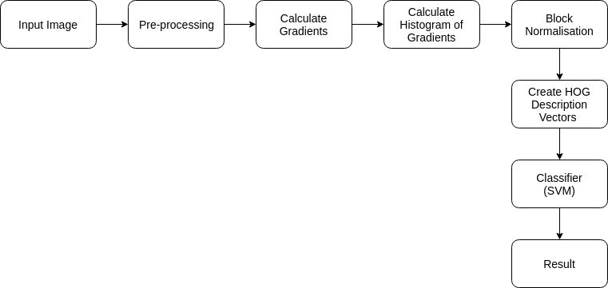Visualization of HOG features

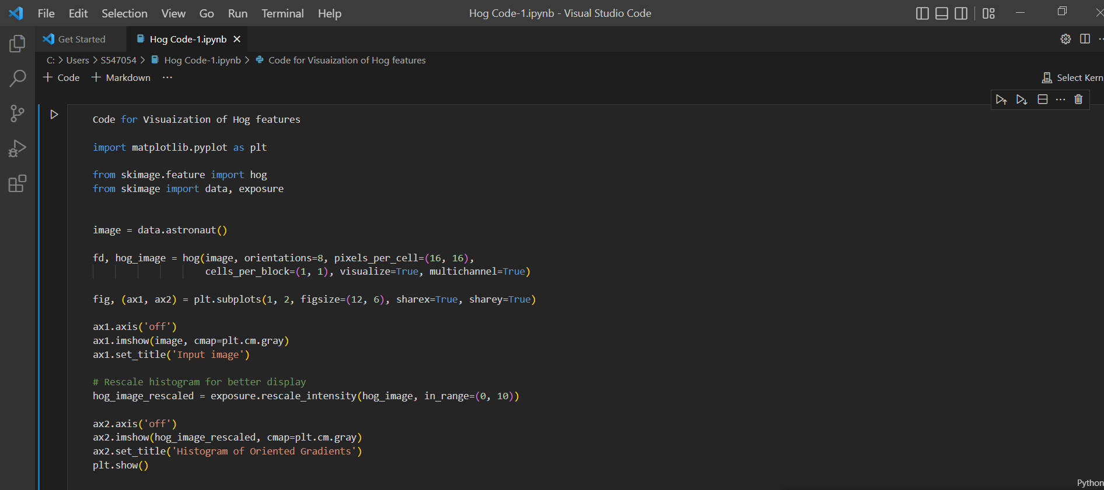

Training Sets
1.Positive training samples
Labeled Faces in the Wild dataset provided by Scikit-Learn consists of variety of faces which is perfect for our positive set.

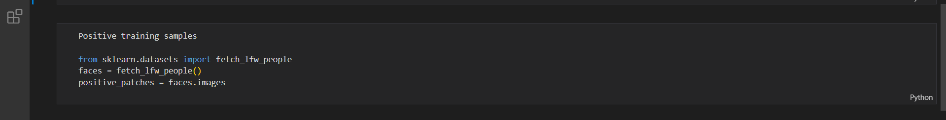
2.Negative training samples
For Negative set we need images without face on them. Scikit-Image offers images which can be used in this case. To increase the size of negative set we extract patches of image at different scale using Patch Extractor from Scikit-Learn.

